**MONEY MANAGER APP**

Note: I have checked the application in both Android and IOS. IOS is more efficient and user-friendly than Android version.

#### Home Page

Alignment on IOS and android version is not matching.

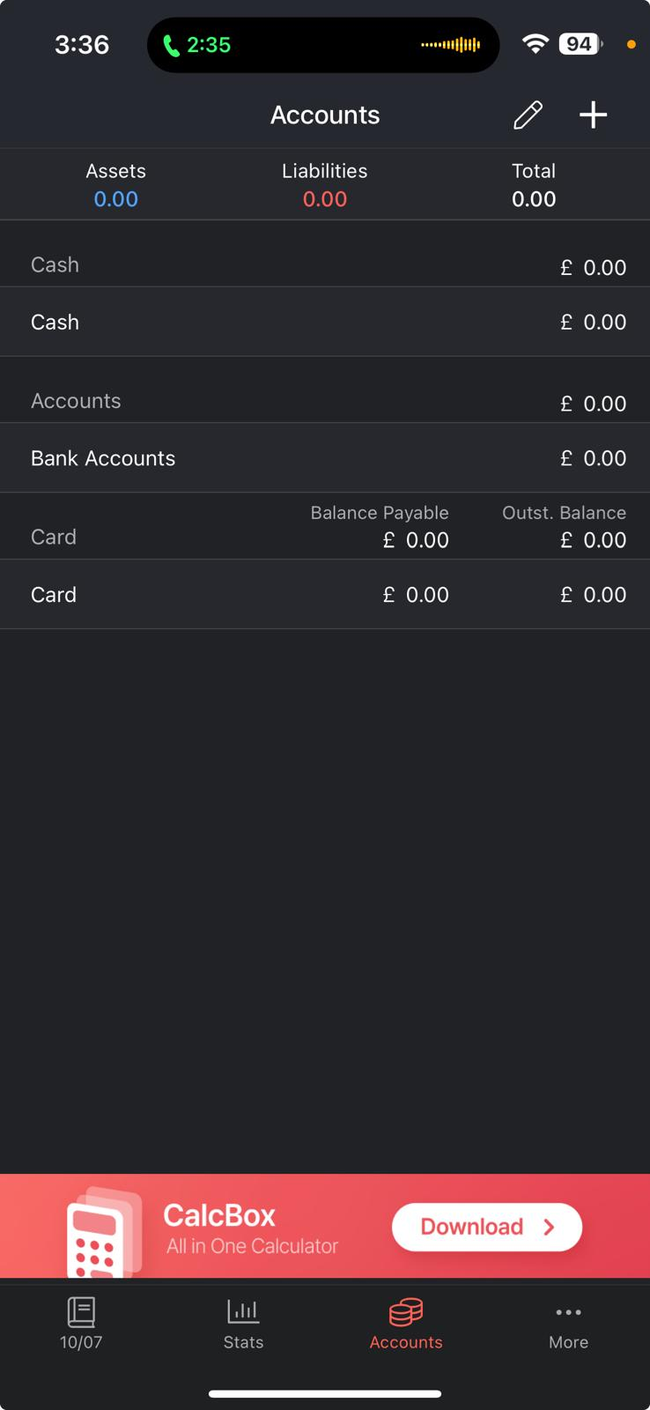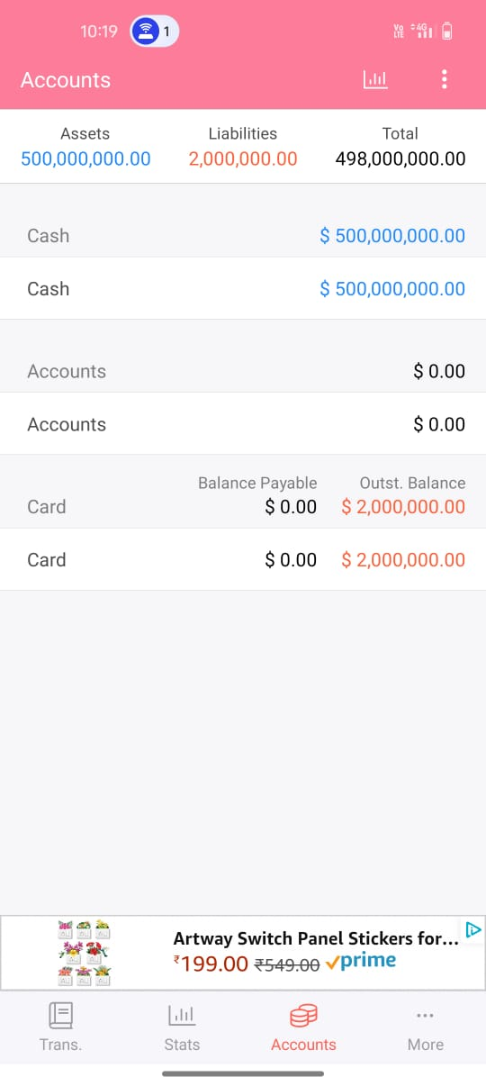

#### Home Page

In Android version Summary tab not included in the Home Page. At the same time Total is included.

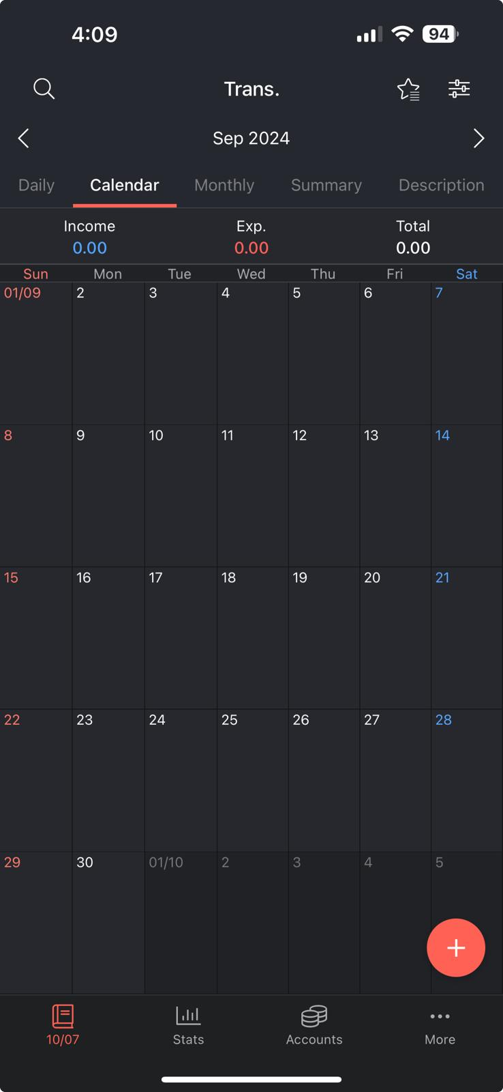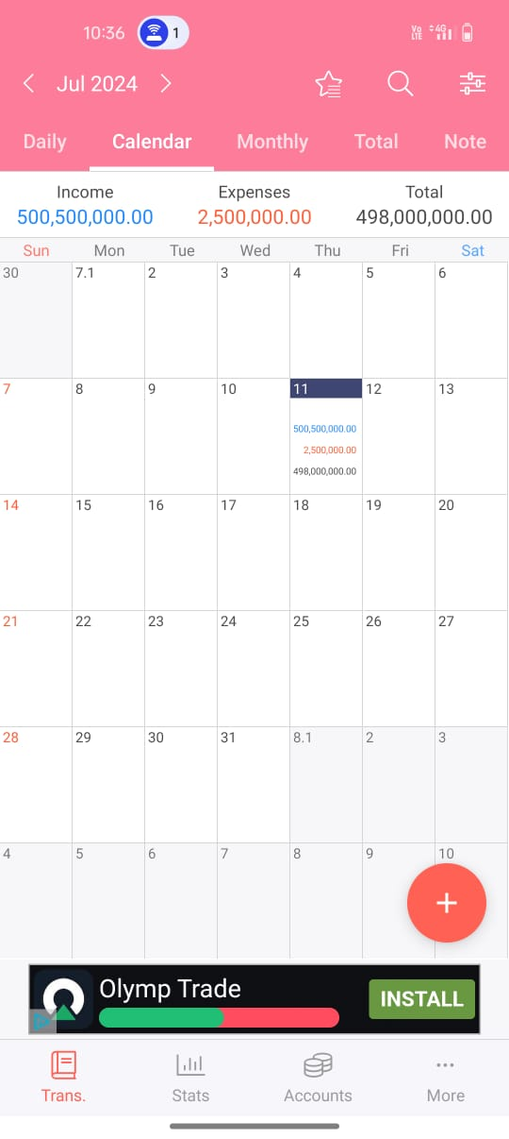

**3. Home Page -**

In Home page, '$' sign missing for 'Income’ ,’Expense’, ‘Total’.

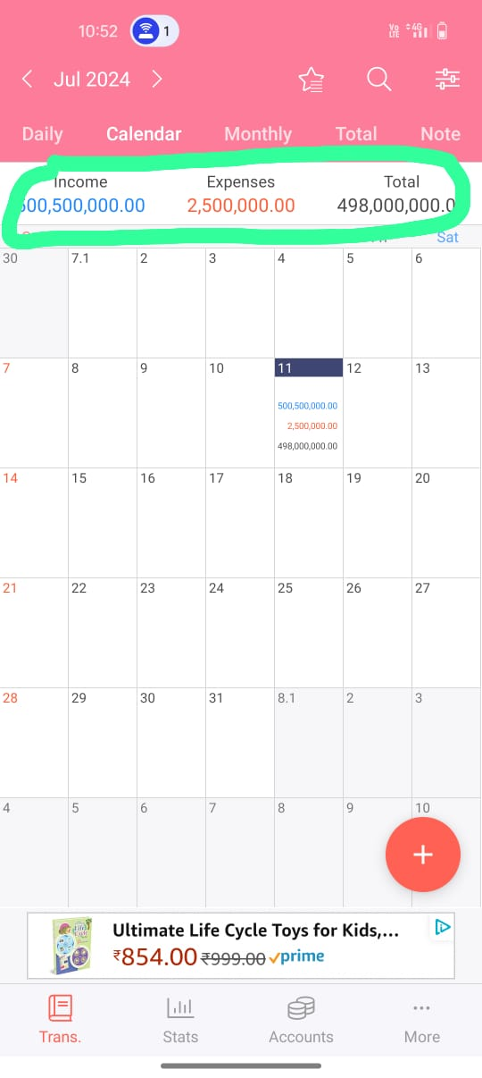

1. **Home Page: Accounts**

When clicking Accounts, 'Edit' option is included in the IOS and not in Android



1. **Home Page: Accounts**

In Account page, 'Liability' ,’Total’ and ‘Assets’ are missing '$' .



1. **Home Page – Trans.**

When reducing the expense amount from cash modified Bal in cash remains same

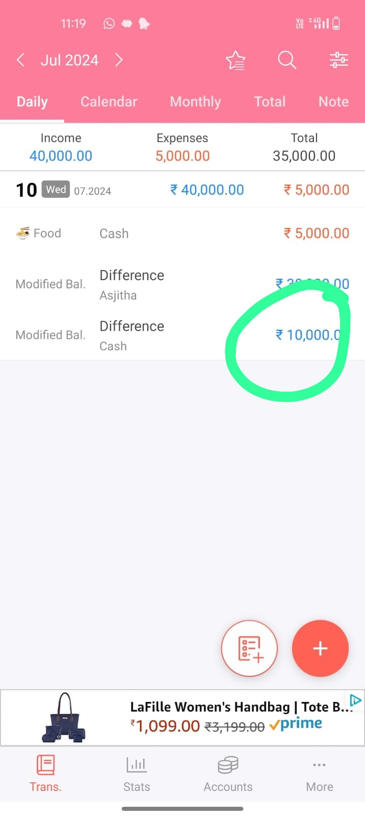

1. **Home Page- Calendar**

When clicking Calendar tab first date on every month is displayed incorrectly

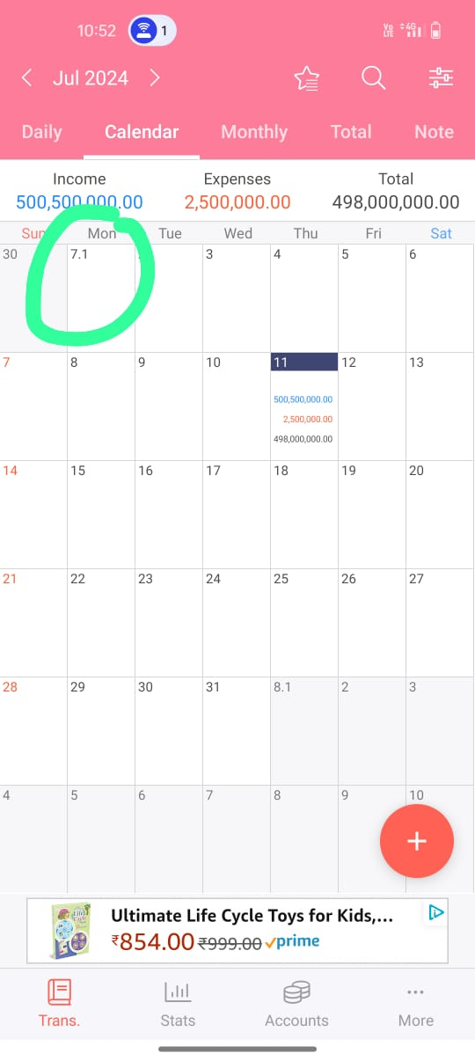

1. **Home Page- Calendar**

'Large Amount is not visible in the calendar

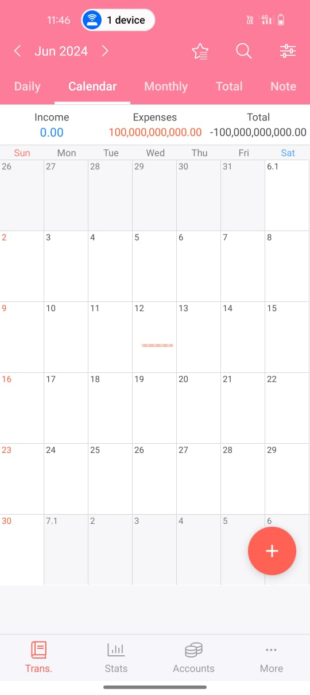

1. **Home Page- Total**

When you click 'Export Data to Excel' on the 'Total' tab, the file downloads. But the Excel file has a duplicate Account column.



1. **Home Page- More**

Setting' heading appears when 'More' tab is clicked

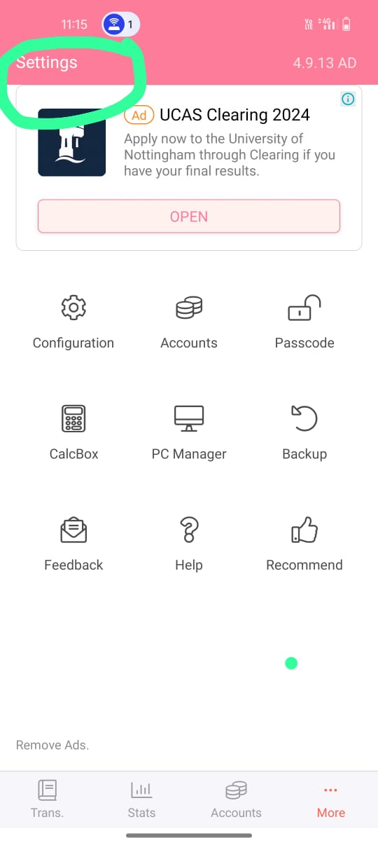

1. **Home Page- More**

Clicking Feedback displays an error message.

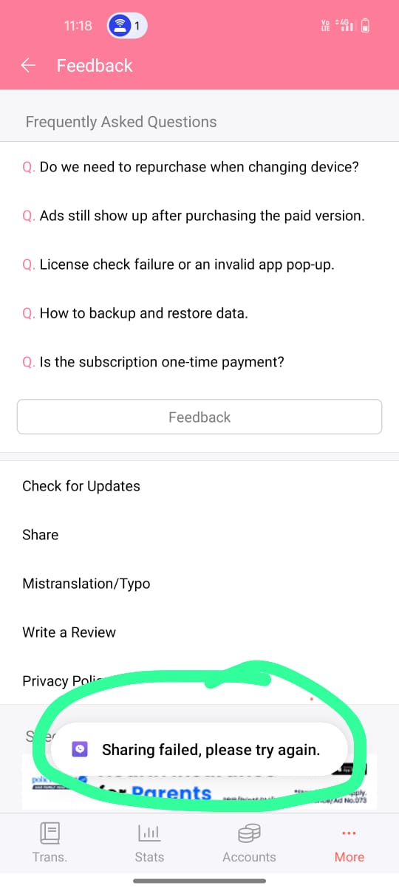

1. **Home Page- More**

Settings page layout issue. '4.9.13 AD' shown in top right corner.

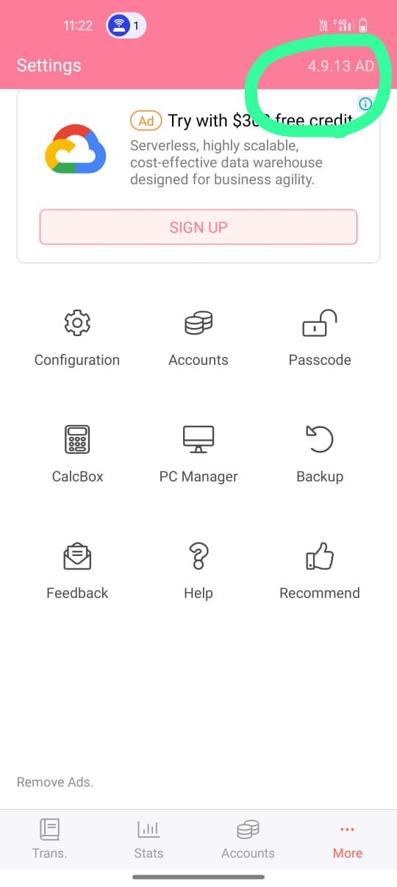

1. **Home Page- More- Accounts**

Heading incorrect on Accounts page: 'Card expenses display config' instead of 'Card expenses display configuration'. And It shows option too (At the time).

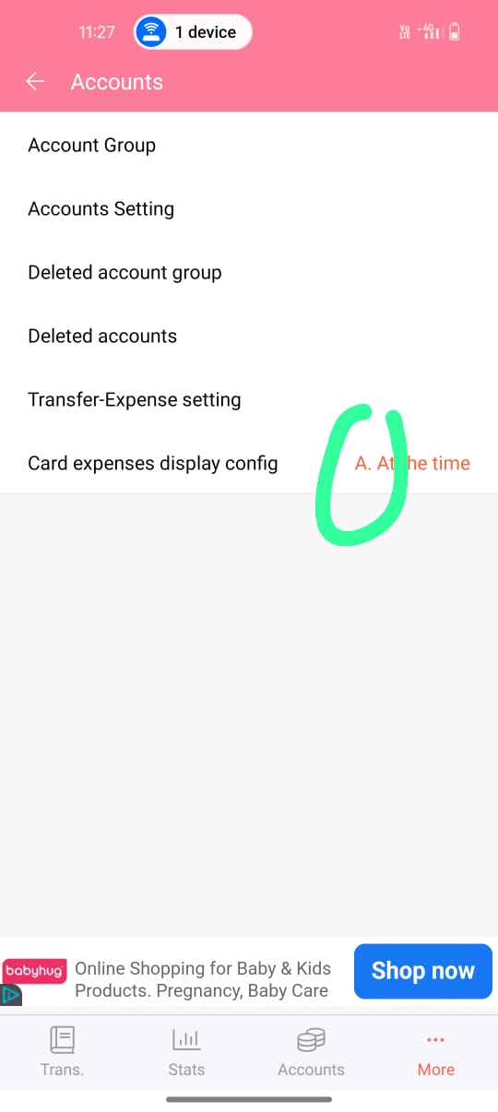

1. **Home Page- More- Accounts**

Delete Account option is not provided in Account Tab

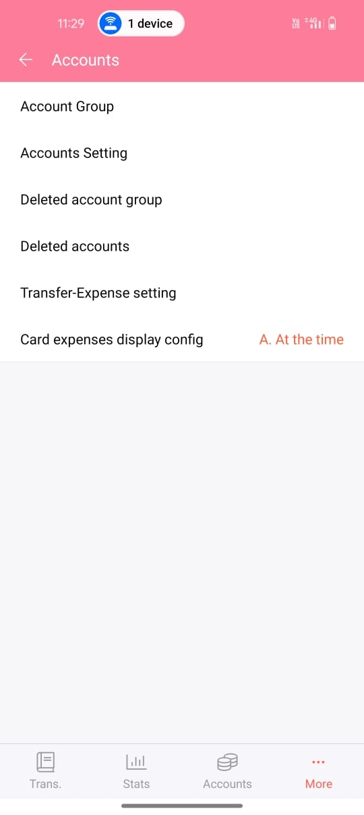

**15 Home Page- More- Account Group**

Not able to add Account groups (investments, Loan, Insurance etc)

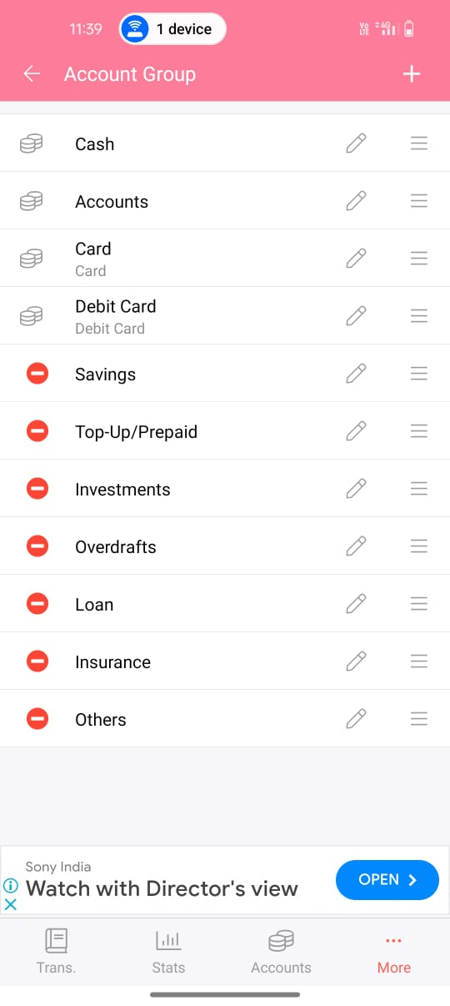

1. **Home Page- More- Note Button setting**

No Changes in Trans tab When clicking ‘Note Button setting’ is OFF

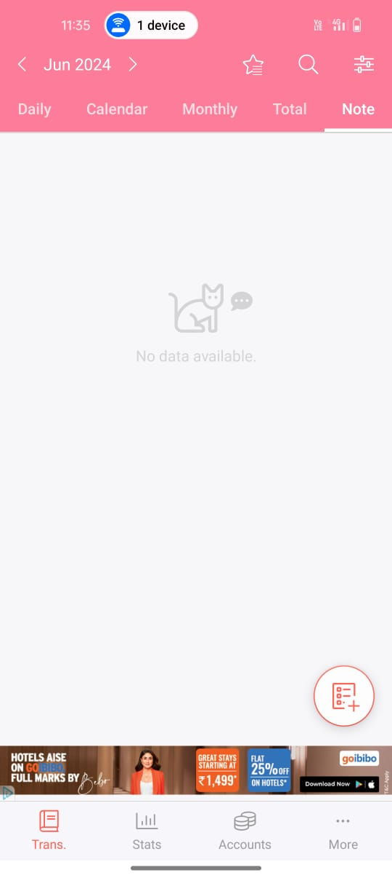

1. **Home Page- More- PC Manager**

Clicking ‘PC Manager’ option in the Settings navigates to 'Premium up grade' page

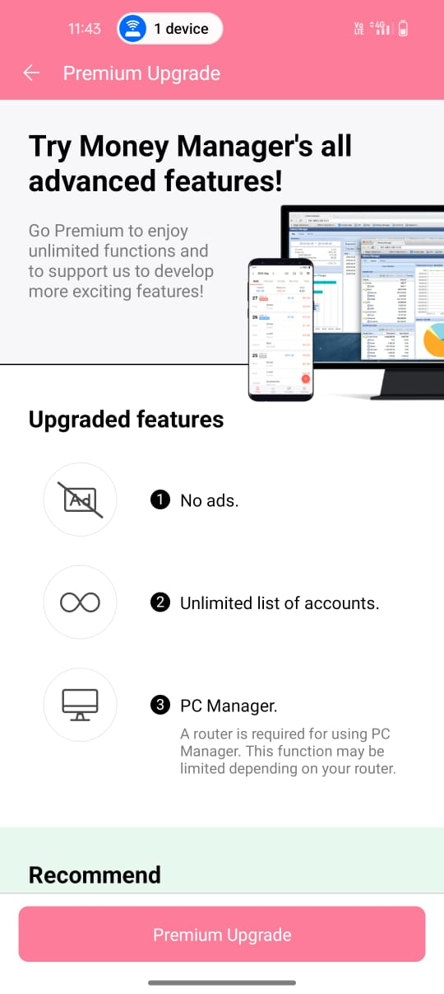

1. **Home Page- Total- Budget setting**

Clicking 'Budget Settings' on Total tab, it displays a message to opens the Total tab.

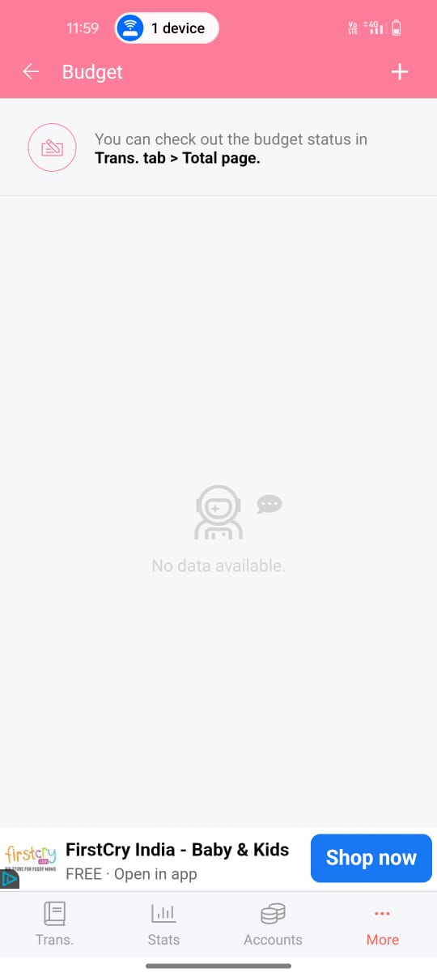

1. **Home Page- More- Recommendation**

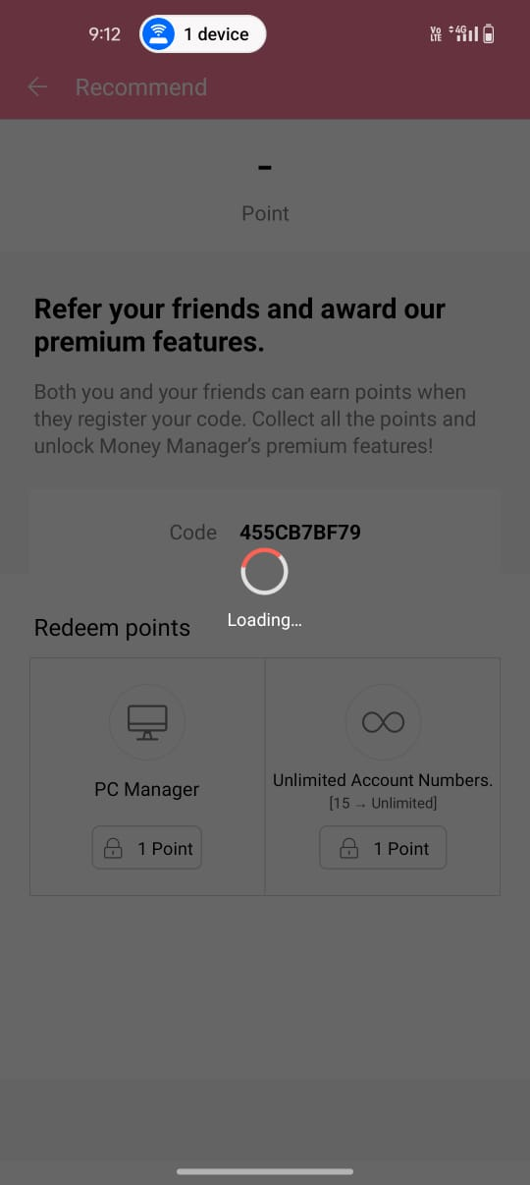When clicking Recommend tab, it take too much time to open